LOVELY PROFESSIONAL UNIVERSITY
(School of Computer Applications)


SALES FORECASTING PROJECT
Predicting Future Retail Sales with Machine Learning
A Data Science Project Report
Submitted by:
ABDUL MAAZID
Registration No.: 12500207
Program: MCA
Time-Series Analysis | Feature Engineering | Regression Modelling | Forecasting

Table of Contents
1. Executive Summary 3
2. Introduction 4
3. Dataset Description 5
4. Data Cleaning and Preparation 6
5. Exploratory Data Analysis 7
6. Feature Engineering 8
7. Modelling Methodology 9
8. Model Results and Comparison 10
9. Feature Importance Analysis 11
10. 30-Day Sales Forecast 12
11. Conclusion and Recommendations 13
12. Appendix A: Data Dictionary 14
13. Appendix B: Engineered Feature Reference 15

1. Executive Summary
This report documents an end-to-end sales forecasting project built on historical store transaction data. The goal was to convert raw, transaction-level records into a daily sales time series, engineer predictive features, train and compare multiple regression models, and produce a 30-day forward sales forecast.
The dataset comprised 2,121 cleaned transaction records spanning 2014 to 2017. After aggregating to daily totals and engineering calendar and lag-based features, three models were trained and evaluated: Linear Regression, a Decision Tree Regressor, and a Random Forest Regressor. The Random Forest model achieved the best results, with a Mean Absolute Error (MAE) of $617.59 and the only positive R² score (0.080) among the three models, and was used to generate the final 30-day forecast.
Feature importance analysis showed that recent sales history — particularly sales from seven days prior — was the strongest predictor of near-term sales, more influential than long-range calendar position such as year or quarter. The overall forecasting accuracy was constrained by high day-to-day volatility in the underlying sales data, a limitation discussed in the conclusions and recommendations.

Key Results at a Glance
Metric | Value
Records analysed | 2,121
Date range | 2014 – 2017
Best model | Random Forest Regressor
Best MAE | $617.59
Best R² score | 0.080
Forecast horizon | 30 days

2. Introduction

2.1 Background
Accurately forecasting sales is central to inventory planning, staffing, and revenue management for any retail business. Sudden demand spikes or downturns that are not anticipated lead to stockouts, excess inventory, or missed revenue targets. This project applies a data-driven, machine-learning approach to forecast daily sales using a store's historical transaction record.

2.2 Objectives
- Consolidate raw transaction-level data into a clean, continuous daily sales time series.
- Explore sales trends at daily and monthly resolution to understand underlying patterns.
- Engineer calendar-based and lag-based features suitable for supervised regression.
- Train and benchmark multiple regression models on held-out test data.
- Identify which features most strongly drive sales predictions.
- Generate a 30-day forward sales forecast using the best-performing model.

2.3 Scope and Tools
The analysis was carried out in Python using pandas and NumPy for data manipulation, matplotlib and seaborn for visualization, and scikit-learn for model training and evaluation (Linear Regression, Decision Tree Regressor, and Random Forest Regressor). All work was performed in a single Jupyter/Colab notebook, from raw CSV ingestion through to the final 30-day forecast.

3. Dataset Description
The source dataset is a store sales transaction file (stores_sales_forecasting.csv) containing 2,121 rows and 21 columns after de-duplication. Each row represents a single line item within a customer order.

3.1 Field Summary
Field | Description
Order Date / Ship Date | Transaction and shipment dates
Ship Mode | Shipping method used
Customer ID / Name / Segment | Customer identity and segment
Region / State / City | Geographic location of the order
Category / Sub-Category / Product Name | Product classification
Sales | Revenue for the line item (target variable)
Quantity / Discount / Profit | Order economics

3.2 Descriptive Statistics — Sales
Statistic | Value
Count | 2,121
Mean | $349.83
Std. Deviation | $503.18
Minimum | $1.89
25th Percentile | $47.04
Median | $182.22
75th Percentile | $435.17
Maximum | $4,416.17
Sales values are right-skewed — the median ($182.22) is well below the mean ($349.83), indicating a small number of large orders pull the average upward. This skew is a typical characteristic of retail transaction data and is one reason regression models trained on daily totals face elevated error metrics.

4. Data Cleaning and Preparation
Before analysis, the raw transaction data was cleaned and restructured into a continuous daily time series suitable for time-series feature engineering:
- Missing values: verified there were zero missing values across all 21 original fields.
- Duplicates: identified and removed fully duplicated transaction rows.
- Date typing: converted the Order Date column from text to a proper datetime type.
- Chronological sort: sorted all records in ascending order by Order Date.
- Daily aggregation: grouped transactions by date and summed Sales to produce one total-sales value per calendar day.
- Calendar completion: reindexed the series to a continuous daily frequency, filling days with no recorded transactions with $0 in sales, so the series contains no date gaps.
This produced a clean, gap-free daily sales series covering the full 2014–2017 window, which forms the foundation for all subsequent trend analysis, feature engineering, and modelling.

5. Exploratory Data Analysis

5.1 Daily Sales Trend
Plotting the cleaned daily sales series reveals substantial day-to-day volatility, with sales spiking on some days and dropping near zero on others. This volatility is expected given the transaction-level nature of the data and directly informs the decision to engineer lag-based features that capture recent momentum.
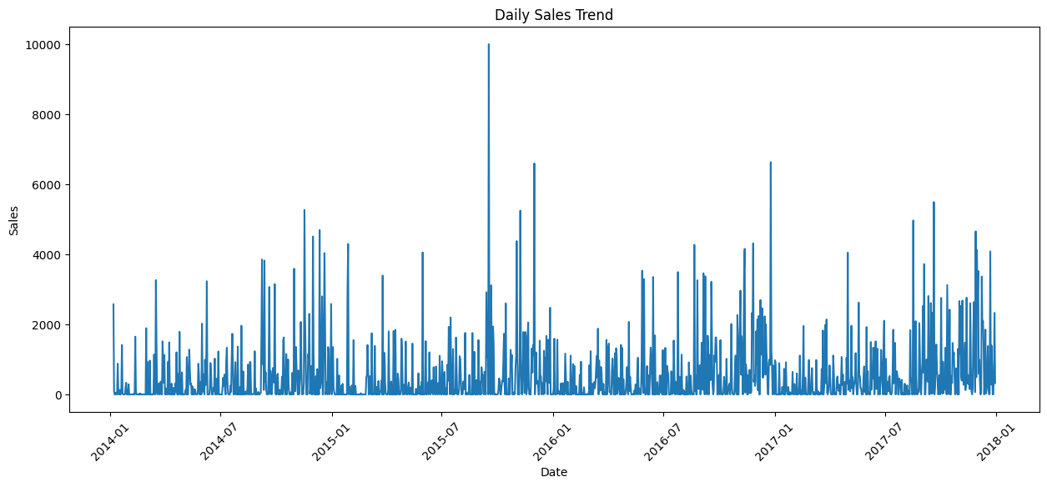
Figure 1. Daily sales trend, 2014–2017.

5.2 Monthly Sales Trend
Aggregating sales to a monthly resolution smooths out daily noise and exposes a clearer underlying pattern, including recurring seasonal peaks and an overall upward trajectory across the four-year window. This view supports the use of calendar features such as Month and Quarter in the predictive models.
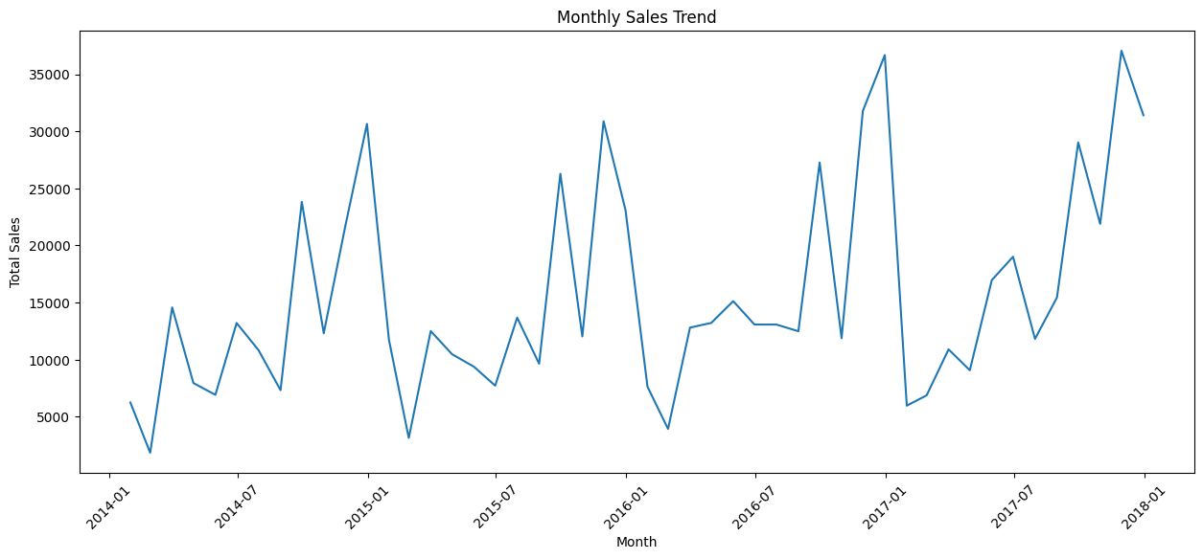
Figure 2. Monthly sales trend, 2014–2017.

6. Feature Engineering
Two complementary families of features were engineered from the cleaned daily sales series to give the models both calendar context and short-term memory of recent sales activity.

6.1 Calendar Features
- Year — captures long-term growth trends across the dataset.
- Month — captures seasonal effects within a year.
- Day — captures within-month patterns such as month-end effects.
- Day of Week — captures weekday versus weekend demand differences.
- Quarter — captures broader seasonal or fiscal-period effects.

6.2 Lag Features
- Previous Day Sales (t-1) — the most recent day's total sales.
- Sales 7 Days Ago (t-7) — same weekday in the prior week, capturing weekly cyclicality.
- Sales 30 Days Ago (t-30) — sales roughly one month prior, capturing longer-term momentum.
Rows without complete lag history (the first 30 days of the series) were dropped, since they lacked the historical values needed to compute all lag features. The final feature set used for modeling combined all five calendar features with all three lag features.

7. Modelling Methodology

7.1 Train/Test Split
The engineered dataset was split chronologically, with the first 80% of days used for training and the final 20% held out for testing. A chronological (rather than random) split was used to reflect the real-world forecasting scenario, where models are trained on the past and evaluated on unseen future data.

7.2 Models Evaluated
- Linear Regression — a baseline linear model capturing straightforward relationships between features and sales.
- Decision Tree Regressor (max depth 10) — a non-linear model capable of capturing feature interactions and thresholds.
- Random Forest Regressor (100 trees, max depth 15) — an ensemble of decision trees that reduces overfitting and typically improves generalization over a single tree.

7.3 Evaluation Metrics
- MAE (Mean Absolute Error) — the average absolute difference between predicted and actual sales, in dollars.
- RMSE (Root Mean Squared Error) — similar to MAE but penalizes larger errors more heavily.
- R² Score — the proportion of variance in sales explained by the model; 1.0 is a perfect fit, 0 means no better than predicting the average, and negative values indicate the model performs worse than that baseline.

8. Model Results and Comparison
All three models were trained on the same 80% training window and evaluated on the same held-out 20% test window. Results are summarized below.
Model | MAE | RMSE | R² Score
Linear Regression | $638.96 | $938.65 | 0.059
Decision Tree | $714.77 | $1,123.43 | -0.348
Random Forest (Best) | $617.59 | $928.08 | 0.080
The Random Forest model produced the lowest MAE and RMSE and the only positive R² score of the three, making it the strongest performer and the model selected for generating the final forecast. The Decision Tree's negative R² indicates it performed worse than simply predicting the average sales value for every test day, likely due to overfitting on the relatively small and volatile training set. All three models exhibit elevated error relative to typical daily sales values, which reflects the inherent day-to-day volatility identified during exploratory analysis rather than a modeling defect specific to any one algorithm.

8.1 Actual vs. Predicted Sales
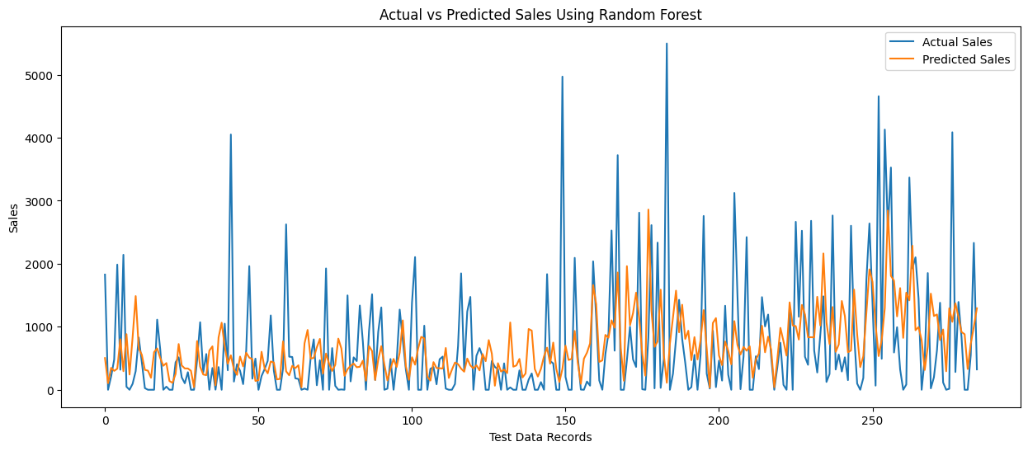
Figure 3. Actual vs. predicted sales on the test set, Random Forest model.

9. Feature Importance Analysis
The Random Forest model's built-in feature importance scores indicate how much each feature contributed to reducing prediction error across the ensemble of trees.
Feature | Importance
Sales 7 Days Ago | 0.222
Day | 0.179
Previous Day Sales | 0.153
Month | 0.140
Sales 30 Days Ago | 0.122
Day of Week | 0.109
Year | 0.055
Quarter | 0.019
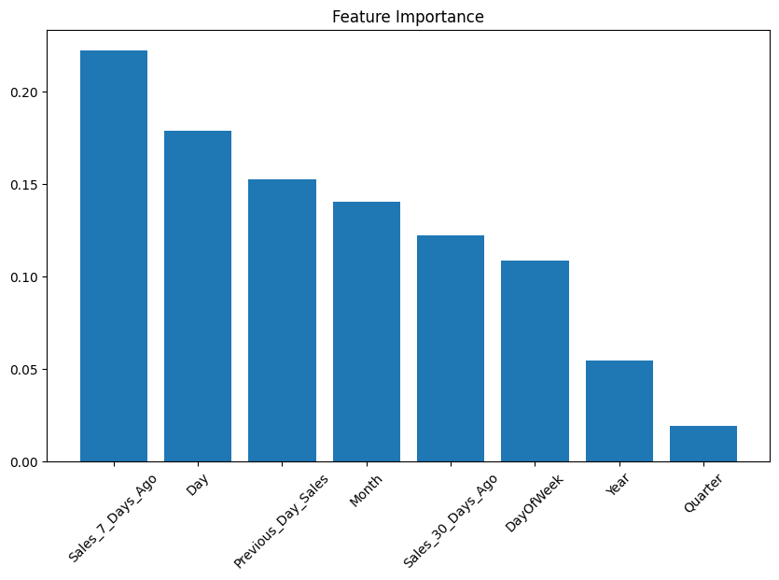
Figure 4. Feature importance ranking, Random Forest model.
Sales from seven days prior is the single strongest predictor, followed by the day-of-month and previous-day sales. Together, the three lag features and the Day feature account for the majority of predictive power, while Year and Quarter contribute comparatively little. This suggests that recent sales momentum, rather than broad calendar position, is the primary driver of near-term sales in this dataset.

10. 30-Day Sales Forecast
Using the trained Random Forest model, a 30-day forward forecast was generated for the period immediately following the last date in the dataset (December 30, 2017). Each day's forecast was produced iteratively: predicted sales for a given day were fed back into the lag features used to forecast subsequent days.
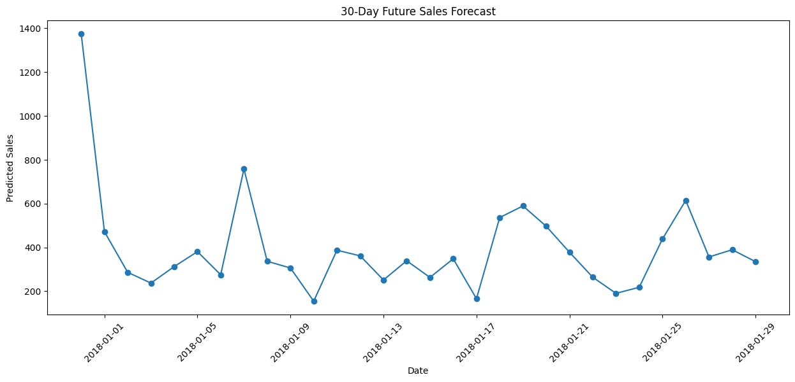
Figure 5. 30-day future sales forecast, December 31, 2017 – January 29, 2018.
The forecast projects daily sales ranging from roughly $154 to $1,374 over the 30-day window, with several mid-range spikes around mid- and late-January consistent with the weekly cyclicality identified in the feature importance analysis. As with the historical data, forecast values remain volatile day-to-day rather than following a smooth trend, reflecting the same underlying demand variability observed in the training data.

11. Conclusion and Recommendations

11.1 Conclusion
This project successfully built an end-to-end pipeline from raw transaction data to a 30-day sales forecast. The Random Forest Regressor outperformed both Linear Regression and a single Decision Tree, and feature importance analysis confirmed that recent sales history is the dominant driver of near-term forecasts. However, all models achieved relatively low R² scores, indicating that daily sales in this dataset are difficult to predict precisely from calendar and lag features alone — a substantial share of day-to-day variance remains unexplained.

11.2 Recommendations
- Incorporate external drivers such as promotions, holidays, and marketing calendars, which likely explain some of the currently unmodeled volatility.
- Evaluate gradient boosting methods (e.g., XGBoost, LightGBM), which often outperform Random Forest on tabular time-series problems.
- Forecast at a weekly rather than daily granularity to reduce noise and improve model stability.
- Incorporate product category and regional breakdowns to capture heterogeneous demand patterns masked by store-wide daily totals.
- Expand lag and rolling-window features (e.g., 7-day and 30-day moving averages) to give the models smoother momentum signals.
- Retrain and re-validate the model periodically as new transaction data becomes available, to maintain forecast accuracy over time.

12. Appendix A: Data Dictionary
The table below documents every field present in the original transaction-level dataset before aggregation to daily sales.
Field | Type | Description
Row ID | Integer | Unique row identifier
Order ID | Text | Identifier shared by all line items in one order
Order Date | Date | Date the order was placed
Ship Date | Date | Date the order shipped
Ship Mode | Text | Shipping method (e.g., Standard, Second Class)
Customer ID / Name | Text | Customer identifier and name
Segment | Text | Customer segment (e.g., Consumer)
Country / State / City | Text | Order geography
Postal Code | Integer | Shipping postal code
Region | Text | Sales region (e.g., South, West)
Product ID / Name | Text | Product identifier and name
Category / Sub-Category | Text | Product classification
Sales | Float | Revenue for the line item (USD)
Quantity | Integer | Units sold in the line item
Discount | Float | Discount rate applied
Profit | Float | Profit for the line item (USD)

13. Appendix B: Engineered Feature Reference
The table below lists every feature used to train the regression models, along with the modeling rationale for including it.
Feature | Type | Purpose
Year | Calendar | Captures long-term growth across the 2014–2017 window
Month | Calendar | Captures within-year seasonality
Day | Calendar | Captures within-month patterns
Day of Week | Calendar | Captures weekday vs. weekend demand
Quarter | Calendar | Captures broader seasonal/fiscal cycles
Previous Day Sales | Lag (t-1) | Short-term sales momentum
Sales 7 Days Ago | Lag (t-7) | Weekly cyclicality
Sales 30 Days Ago | Lag (t-30) | Monthly-scale momentum
Together, these eight features formed the input matrix (X) used to predict daily Sales (y) across all three models evaluated in Section 8.

Glossary
- Time series — a sequence of data points indexed in chronological order, here one total-sales value per calendar day.
- Lag feature — a feature built from a past value of the target variable, used to give a model memory of recent history.
- Regression — a supervised learning task that predicts a continuous numeric value, here daily sales in dollars.
- Ensemble model — a model, such as Random Forest, that combines predictions from many individual models (here, decision trees) to improve accuracy and reduce overfitting.
- Overfitting — when a model learns patterns specific to its training data that do not generalize to new, unseen data — evidenced here by the Decision Tree's negative test-set R².

